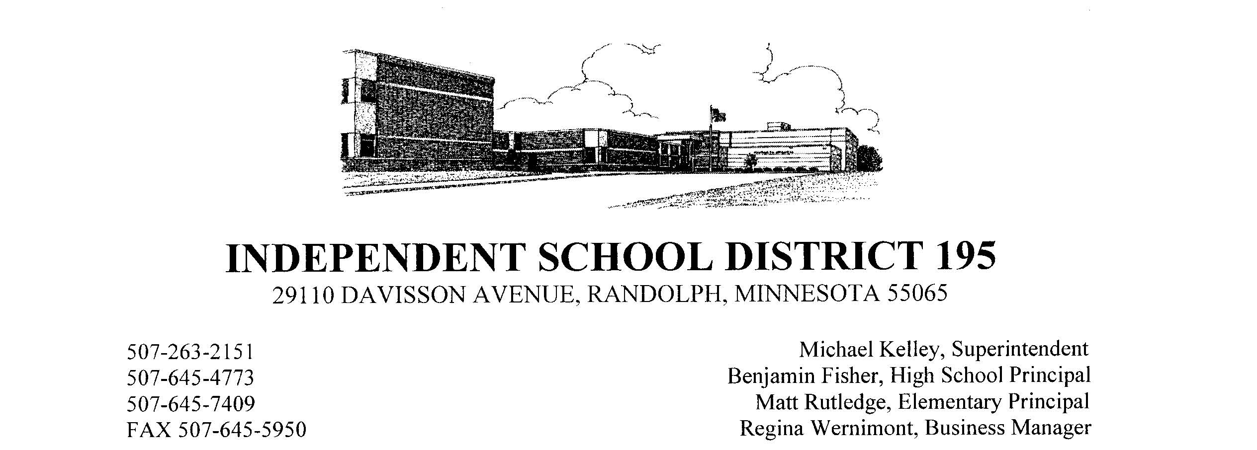

Healthy Changes in Our School Cafeterias!
Dear Randolph Families:
This fall, Randolph school cafeterias are meeting challenging new federal nutrition standards for school meals, ensuring that meals are healthy and well-balanced and provide students all the nutrition they need to succeed at school. Now is a great time to encourage your kids to choose school lunch!

School meals offer students milk, fruits and vegetables, proteins and grains, and they must meet strict limits on saturated fat, trans fat and portion size. Starting in School Year 2012-2013, school lunches will meet additional standards requiring:
- Age-appropriate calorie limits.
- Larger servings of vegetables and fruits (students must take at least one serving of produce).
- A wider variety of vegetables, including dark green and red/orange vegetables and legumes.
- Fat-free or 1% milk (flavored milk must be fat-free).
- More whole grains.
- And less sodium.
We know that at times change can be hard. Some of the more apparent changes that students will see include, a limit on the of bread/grain items now served, stricter control on meat/meat alternate (protein) serving sizes, unlimited fruits and/or vegetable servings, removal of salt shakers at lunch. But with your support, we can be sure that children adopt the kind of healthful eating habits and lifestyles that will enable them to live longer, more productive lives.
We look forward to welcoming your children to the cafeteria this fall. Visit the USDA website to find out more about the healthy school meals requirements (http://www.fns.usda.gov/cnd/Governance/Legislation/CNR_2010.htm).
Thank you.

